# OWC R Exercise Research Questions

Your goal is to write a brief memo for TNTP’s project director using RMarkdown answering MCSD’s initial research questions. The answers to question 0 are provided as a working example.

0. [Example] What’s the distribution of ratings in MCSD?

a. Run the provided code – it will create a table when you knit the RMarkdown document.

b. Code is also provided to show this distribution in a chart.

1. Confirm the problem. Is the district losing its highest-performing teachers?

a. Create a table showing the retention rate by final evaluation rating.

| **rating** | | **percent** | **count** |
| --- | --- | --- | --- |
|  |  |  |  |
| **1** | Ineffective | 1.5% | 56 |
| **2** | Minimally Effective | 21.8% | 808 |
| **3** | Developing | 60.3% | 2237 |
| **4** | Proficient | 13.5% | 502 |
| **5** | Highly Effective | 2.9% | 106 |

b. Write 1-2 sentences summarizing the state of the district’s differential retention.

MCSD is retaining a larger proportion of teachers rated “Ineffective” and “Minimally Effective” than those rated “Proficient” or “Highly Effective”. Retention is highest among teachers receiving evaluation scores in the in the center of the scale, “Developing”.

2. Explore the relationship between teacher experience and performance.

a. Create a figure showing the relationship between years of experience and evaluation score.

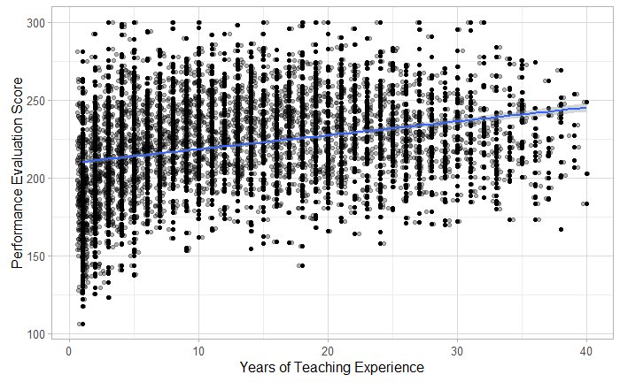

b. Write 1-2 sentences summarizing this relationship.

Teachers with more years of experience have only slightly higher performance evaluation scores, on average.

3. Document the (lack of) relationship between highest degree held and teacher performance.

a. Create a figure showing the relationship between degree and evaluation score.

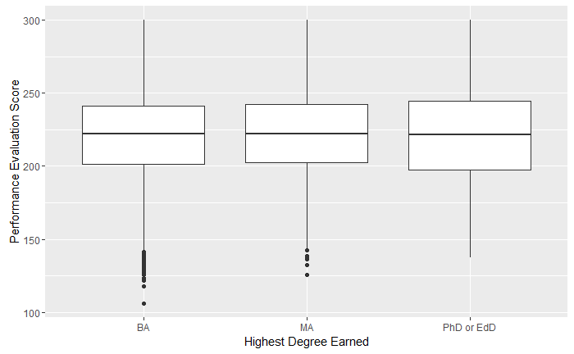

b. Write 1-2 sentences summarizing this relationship.

The highest degree a teacher hold has no significant impact on their evaluation score. There is only a >/= 1 point difference in mean evaluation score across all degree type groups. Teachers with a BA had an average score of 220.4, those with an MA 221.8, and those with a PhD or EdD a 222.3.

4. Explore the connection between performance and compensation.

a. Create a figure showing the relationship between evaluation score and salary.

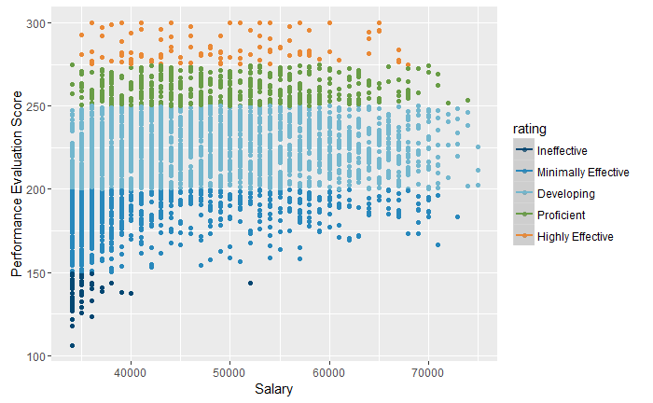

b. Write 1-2 sentences summarizing the relationship between performance and compensation.

There is no significant relationship between teacher performance and compensation. There is a wide distribution of salaries across evaluation scores.

5. BONUS: Contrast the differences between early- and late-career teachers in performance and in pay.

a. Create two figures for comparison: one showing the distribution of performance for each group

(early- and late-career teachers), and the other showing the distribution of salary for each group.

